
OLD OWENS CRICKET CLUB 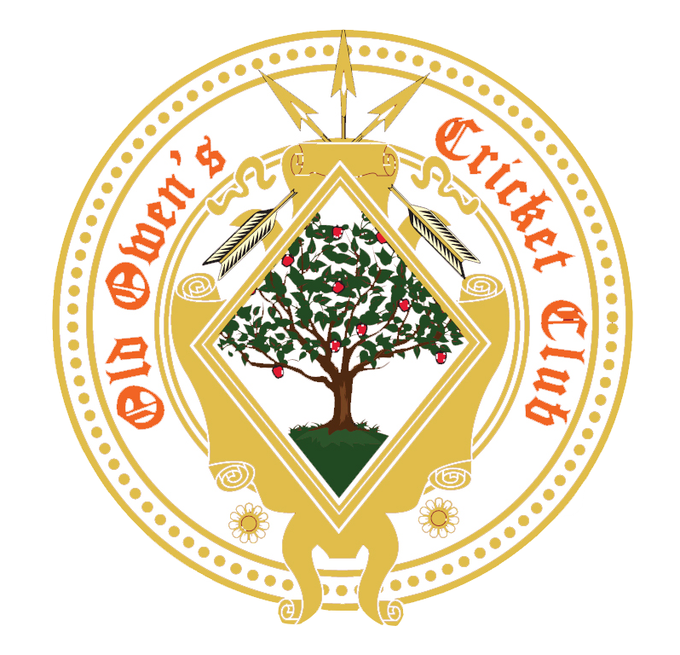

Senior Membership Form

We are very pleased to welcome you to OLD OWENS CRICKET CLUB.
To ensure that we have the correct contact details for you, please insert the information requested below and return this form to your team captain. If you are under 16 please also ask your parents or guardian to sign this form before it is returned.
We will also use this information to ensure that you are kept informed about club events.

Players Details

Name: ……………………………………………………………………………………………………………………………

Date of birth: ……………………………………….

Address: …………………………………………………………………………………………………………………………

……………………………………………………………………………………………………………………………………

Postcode: …………………………

Mobile: ……………………………………………… email: ……………………………………………………………………

Gender: Male Female Unspecified

Category of Membership: Please tick appropriate box
Association membership = £22.00
Full Playing Senior = £100
Full Playing Senior (Under 21) = £50
Father of junior member = £50
Please tick appropriate box
Cash
Card
Old OwensCricket Club Bank Details for On line Payment
Metro Bank
Account No.44029987
Sort Code(23-05-80)
Payment by:Bank TransferCheque

Medical information

Please detail below any important medical information or dietary requirements that our coaches/junior coordinator should be aware of (e.g. epilepsy, asthma, diabetes, allergies etc.)

……………………………………………………………………………………………………………………………………………………………

……………………………………………………………………………………………………………………………………………………………

EMERGENCY CONTACT DETAILS

Please insert the information below to indicate the person(s) who should be contacted in case of an incident/accident:

Contact name …………………………………………………………………………………………………………

Emergency contact number: ………………………………………………………………………………………………………………….

Photographic Consent

Please be aware that official photographers may be in attendance during games / coaching sessions. They will be easily identifiable. If for any reason you to not wish you or your child / children to be photographed or filmed, please indicate this by ticking the box.

I do not wish myself to be photographed or filmed

If you are happy to be photographed, please tick the relevant box to give permission for use of photos –

Press Releases Official OOCC Publicity (eg Posters) OOCC Official Website

Live streaming

Safeguarding

The clubs safeguarding of young people in Cricket ensures we provide a safe, friendly and enjoyable experience for the children taking part. If you have any concerns of any nature, please contact directly the Club’s Safeguarding Officers – Fiona Lane 07711556520 or Debbie Palmer 07778382150

By returning this completed form -

I agree to taking part in the activities of the club.

I understand that I will be kept informed of these activities – for example timing and transport details.

I understand that in the event of any injury or illness all reasonable steps will be taken to deal with that injury/illness appropriately.
I confirm that to the best of my knowledge all information provided in this form is accurate and I will inform the club of any changes to this information in a timely manner.
I confirm that I have received a copy of the club’s Code of Conduct for Members and Guests and agree to abide by it.

For players over 16 years of age (17+)

Signature of Player: …………………………………………………………………………………………………………………

Date: ……………………………………….

For players under 16 years of age

Name of Parent/Guardian: ………………………………………………………………………………………………………………………

Signature of Parent/Guardian: …………………………………………………………………………………………………………………

Date: ……………………………………….

