JUNIOR SECTION MEMBERSHIP 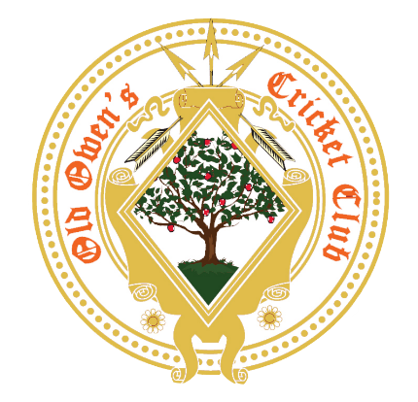
Application and Parental Consent Form

Please complete all sections.

Surname
First name (s)
Date of Birth
Address (including post code)
Parents names
Parents home phone no
Parents mobile no
E-mail address
School and School Year
Does your child have any health problems, allergies, injuries or disability? (if you do not
wish to disclose this on this form, please discuss fully with the Club Safeguarding Officer)
If Yes to any of the above, does your child have a Healthcare Plan? * | *please discuss fully with the Club Safeguarding Officer
Car Reg No: (in case you offer to transport players)
Please tick appropriate box(es) | Junior Member (U17) = £65  Additional Junior Member (U17) = £35
 | Amount Paid: £

Old Owens Cricket Club Bank Details for On line Payment

Metro Bank
Account No. 44029987 Sort Code (23-05-80)
Payment by: Bank Transfer Card Cash

PARENTAL CONSENT SECTION

I/We consent to my/our son/daughter

 | Yes | No
Being provided with First Aid or emergency Treatment - Should your child sustain an injury whilst under the supervision of the club, basic first aid can be provided and the club will endeavour to contact a parent/guardian and also arrange further medical assistance if deemed necessary in the opinion of a
qualified medical practitioner
Photography and or Video recording - This includes:
- video footage being taken in the interests of technical analysis to aid the coaching;
- other video (family records) being taken;
- the taking of photographs which may be used in Club promotional literature, press reports and social media .
- Live streaming of matches to a media platform
Away matches - participation in competitive matches at other clubs. Transport for such events should be organised by parents
Changing Arrangements - Junior cricketers will not be permitted to change/shower in the presence of senior players/members. Use of mobile phones and cameras are not permitted in the changing areas.
Coaching - During the course of technical aspects of coaching it may be necessary, at times, for there to be a minimal amount of physical contact between player and coach. I/We do/do not consent to my/ our son/ daughter taking part in
such coaching

Declarations and Confirmation
Your personal details will be held in accordance with the EU/UK General Data Protection Regulation (GDPR) 2018.
Tick here
I confirm that the information I have provided is accurate.
I, and the Junior Member(s) named below, agree to abide by the various codes of conduct including the “Spirit of Cricket” operated by OOCC. These codes of conduct are available both on the Club House Notice Board and OOCC website.
Name of Junior Section Member
Name of parent/guardian (please print)
Signature of parent/guardian
Date

CONTACT DETAILS OF THE CLUB:

Cricket Development Officer & Head Coach : Chris Palmer Tel No: 07946132772

Email: oocccdo@hotmail.com

Club Safeguarding Officers: Fiona Lane Tel No: 07711556520
: Debbie Palmer Tel No: 07778382150

